No | Task | Status
1. | You cannot create sections and exams in online courses. | DONE  Some code left when update to hosting  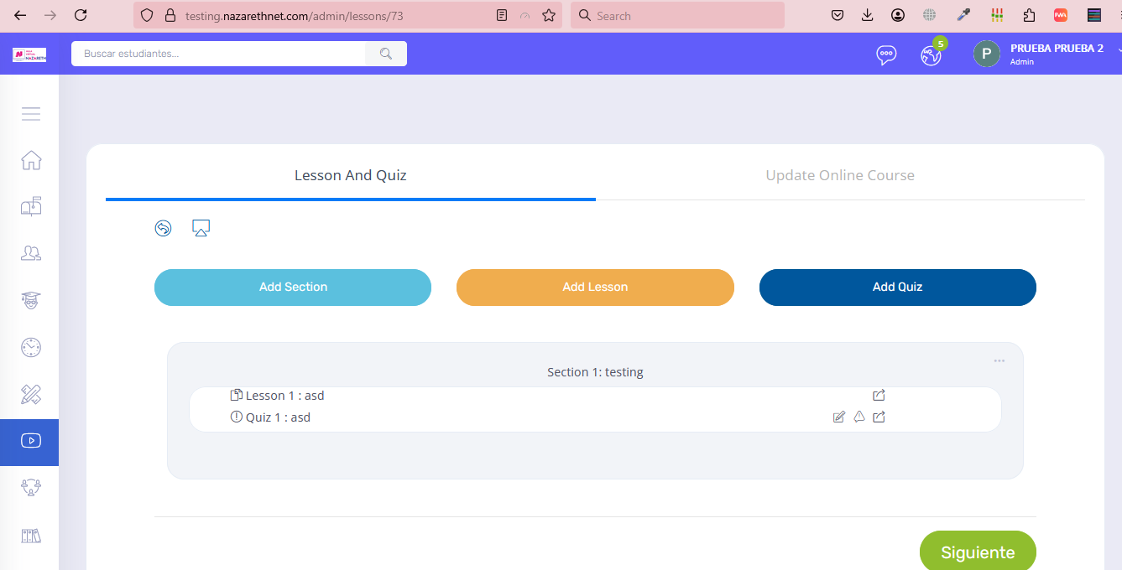
2. | With the student user you cannot view your grade | DONE  Its happened because you set Show Results to Keep Hidden. And system will show “ASK FOR RESULT” Button but this is not button its just information with no action, so i change button to badge for clear information with word ‘Result is hidden’, after admin update exam option Show Results to Show it will appears button to see the view result and i have test it and working correctly.  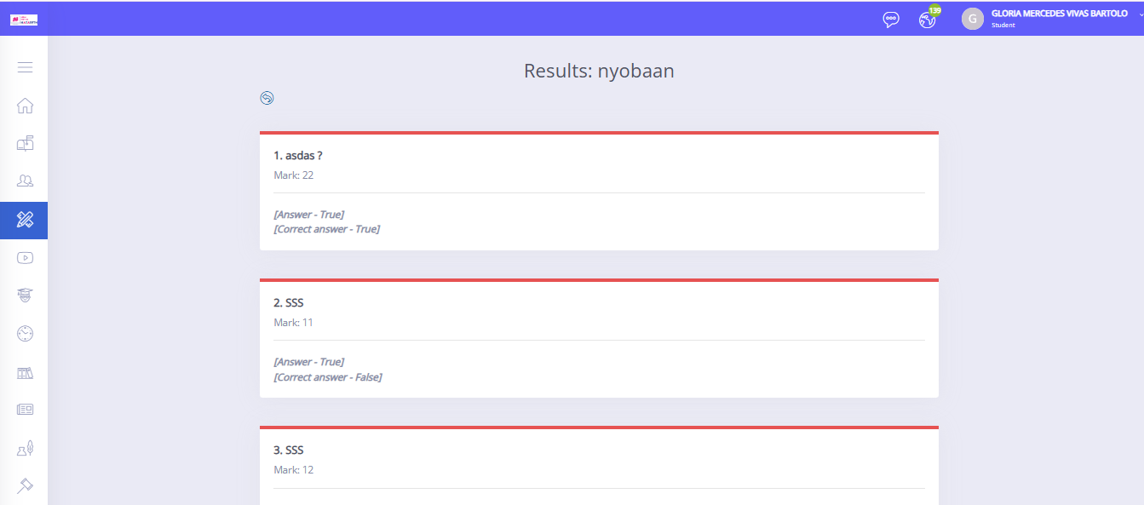
3. | The attendance time still does not match | DONE
4. | The Design certificate still change when update in certificate setting | DONE  You generate a certificate for Student A at 8:00 AM.  Then at 9:00 AM, you update the certificate settings and generate a certificate for Student B.  What happens:  - Student A will still see the certificate with the design from 8:00 AM.  - Student B will get the certificate with the new design from 9:00 AM.  Each certificate keeps the design that was used when it was first created.  Changing the settings later won’t affect certificates that were already generated.
5. | Is it possible to activate an additional sheet that would allow me to add additional details such  as grades, curriculum, etc. I would like to be able to change this manually for some courses,  rather than automatically. | Sorry adding an additional sheet that can be manually customized per course is not possible.  The certificate system is designed for automated and consistent generation. Allowing manual edits for specific courses would compromise that consistency and introduce complexity that the current structure does not allow.
6. | You can also make a separate link only where the certificate validation is projected  https://testing.nazarethnet.com/certificate/check_iframe | DONE  I has fix it This url only certificate validation project page  https://testing.nazarethnet.com/certificate/check_iframe
7. | It is not working when downloading all the courses  https://testing.nazarethnet.com/admin/export_data | DONE  Some code left when update to hosing
8. | You can add the option for everyone and optionally add download by student name (ATTENDANCE) export data section | DONE
9. | You can add the option for everyone and optionally add download by student name (GRADES) export data section | DONE
10. | a. The online exam grade could not be transferred.  -Student Nancy earned a grade of 20, but the exam and grade did not transfer.-Every time it is detected that it is the same exam, the student must transfer it with the same grade. | DONE  Sorry, maybe there is a misunderstanding here regarding EXAM, the exam you are showing in the photo screenshoot is an online exam and the exam feature in data transfer is the exam scores that are imported in the mark menu so when transferring it will not be carried over, but don't worry I have provided the option  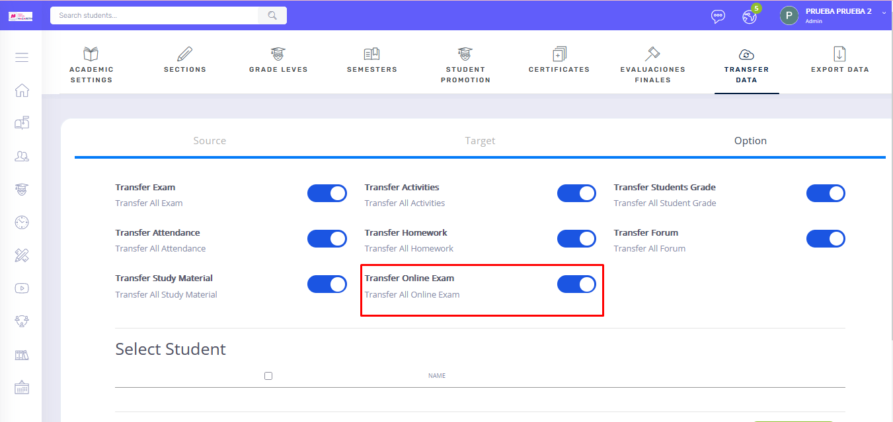
11 | b. In the assignments, student Nancy completed her assignment, but her grade was 20, but it  was not transferred. Every time it is detected that it is the same assignment, the student must  be transferred with the same grade. | Done  It has been fixed. The issue is now resolved  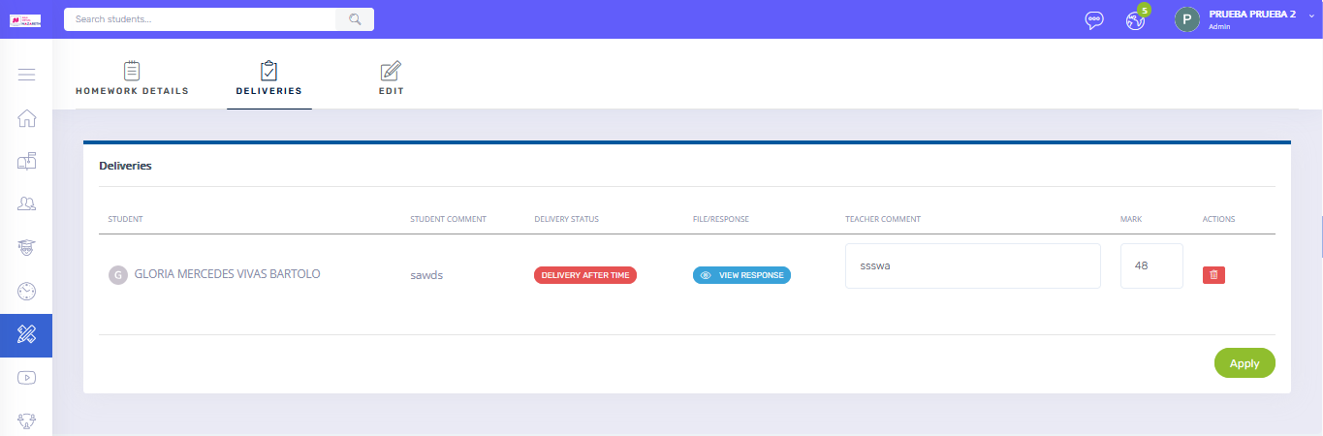  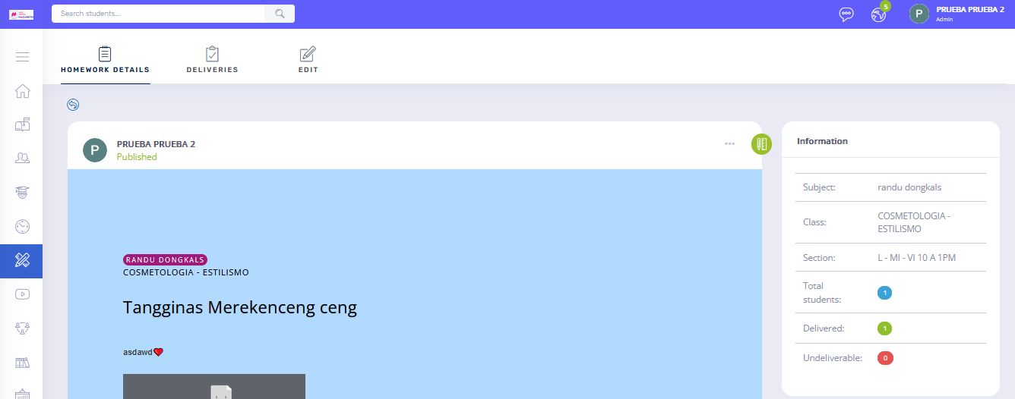
12. | c.Select the option to transfer without activities, however the activities have also been  duplicated. | That's not possible because activities are part of the exam and student grades come from activities. We can't transfer grades without basic activities because the sequence is something like this.  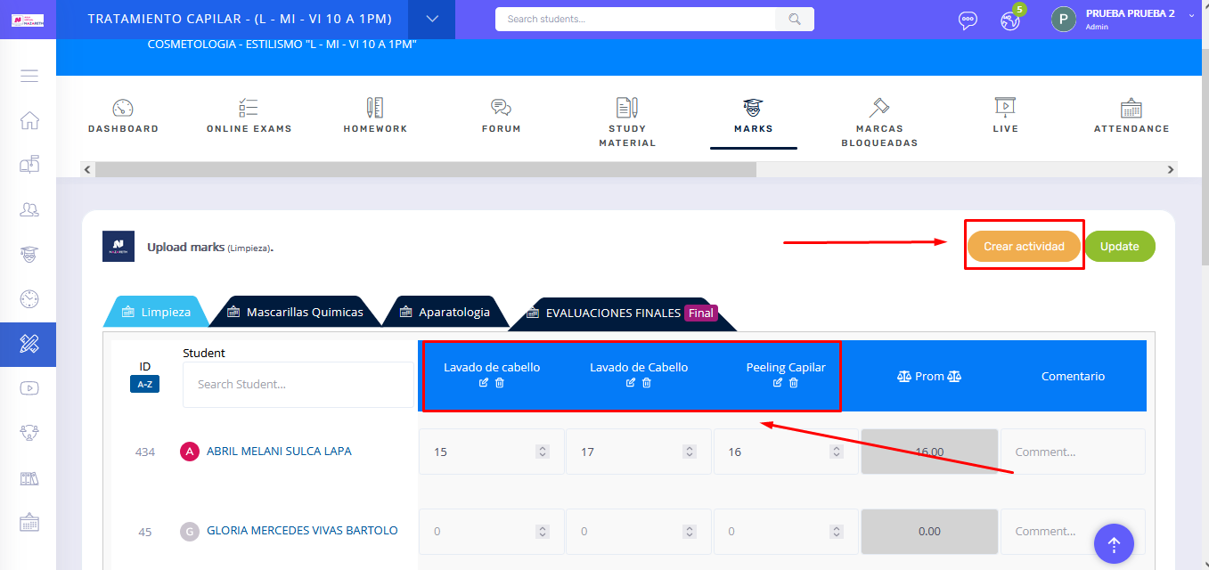
13. | d. Once you transfer a student, this should not be repeated in the previous section. | DONE  When you transfer student not exist in previous section
14. | The page is not working correctly, it does not show the attendances  https://testing.nazarethnet.com/admin/student_profile_attendance/39/8/18/150/6/2024/ | DONE
15. | When assigning the section to the students, these courses can start with inactive | DONE

